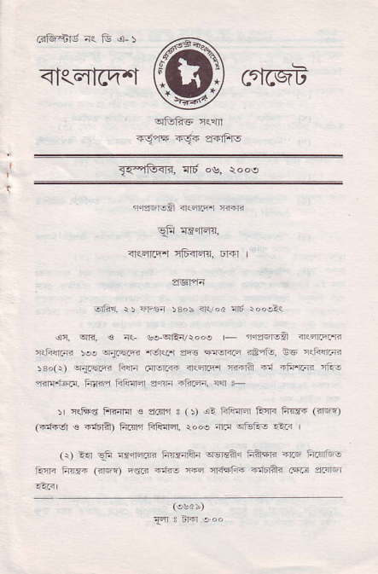
ffi
<l<qrcn--l
T'e.3F r-6.+ $nFl
_{Tr'-lFfi.} 1116 o's. rooe
nra6|g&l ftql.q{ rrF
_{9F} !E{q{,
1<qt{.1 rF<rds, 6r+r I
srfR. _{r t ir{r 53ob <lvod} ^{:flt} laosQ1
_{r<F{raR sr.} ^{cr{FLE} i6{r iB'i-q EG 81F{r{i _{r€o(r)} ^{q{FaF} F{rr .:i1wF n<;nrn {.4r? .r {FF.-r 'ii! ^{?r<r{.:r.Fr.} F <q flrq|qr e.r4n +Fr6. s{r ,-
5r Rfts Frr4qr € sallr s (t i? FlFtr| Enl< ^{ft{rt} Grft) (Ff46r € _{4Jn ficlr'] trlnEr, rocs} ^{ql.{} eFi.i.i.n
(r) ^{-a} _{9ii €"iqr.fi trqrarAa} ^{qee?r} Fraqri mrs tr.I'trF _{EqF FTri} (<16r) Esr< F:tTo ffi 4ffF +1o-Fts _{cs.t} lrElEr
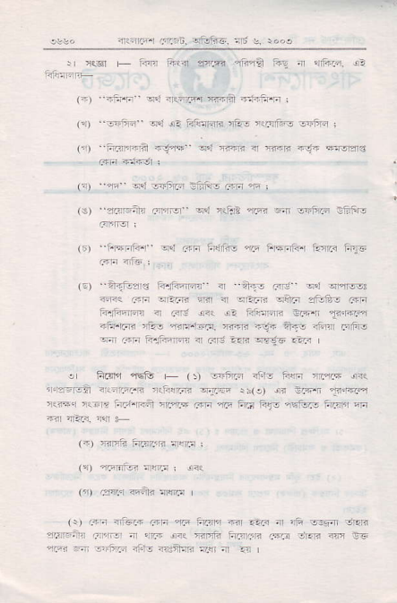
_{ftai-q} /-'n5.6. otufc. !6 e. rooo
J _{rrcr} ⁻ imr ft.(a arF. ^{njina i+E {} _{"]CFI.} i-
_{(?) -Fr.F} ^{qn q&-86{} :FB ^{-fti-rn} I
(!) _{-fF-} ^{q{} e- ftrainFrR rAr r1nfu- -E_m I _{('r)} ^{--,-'z45ra} _{+j*} q,t ^{,ri@} _{<r FF -rT} '-Ecrs
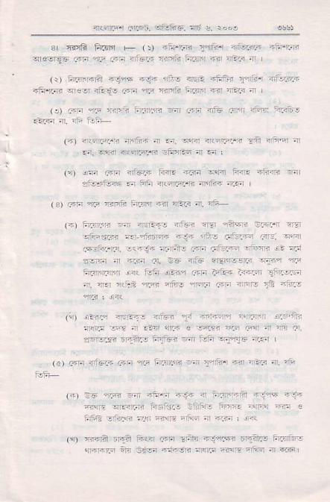
^{(r)} _{ra} .ei -m -liE rF f :
(€) i."F-+r aFFf_ _{e?' afnt} 'i-f. ^{qr} cift/F :FFre
^{(r)} FrFri;r" ^{-"J} F ^{Fr il,Jrjio} _{"r?-q} iFFri{4 Aa.< tuI5 _{"rrn} nfE ;
(o +1tu3r€ turFqFE ir "mF _{rc} qd qr'nr€, ^{@q} _{6F} ^{q-FF} _{sFl <r} ^{qPr:r< qiin} 2r#5 6iri ir.faq@ a c<r! !"< c- ^{FiFFF a.qn} _{Tt} @:n {ft.rF ^{'ii-} FF lT'F_ ffi ^{-ga} *.F nFq Frftj 6 ^{tj1:t4} fr.fq@ 4 _{ao} ^{-..8 q?98} ..I< |
. _{frL"rn ft€ +} (, 6.iB nf.t- Fq1n ry-rF dn{ ^{qiEFE?} _{"rlrr.E} n{FqrF s.lr rn(o) ^{ei €E-tr} lq@L-q ^{,5r"T'..-E:t-y:'} _{?-a} *:. +3 ^,ta.F31 n1-a
^{({)} ctrii i:rartr'R Efij ;
_{tD} n,rtF,e:@: i<{
(jr) /s4.q <'+, r@
(r) ^{.3! {'tu7i FF} _{"w} imri nr E?6 ar rft sqfl G1ER ?vaena _{411ft1} ^{;,r lJl.n} i.< TiEi? FnrnR cFa oF13 @ Es _{ar-} ^{q} 56r.n r'rtr @+n {J. nr .i I
4rir'llrr L.rr.rt r-.F6. rnt !. :oo,
3r {sF fiai51 _{F} (t ^{qr3-E5 r.r nI'} _{.iF} i=,@t
(-.) ii.r5hA 6{n4 +!" _{.ir.'n} ^{qre-r ituF} _{FrF} rF
^{4inE-A} _{lnf.jt} ai-Er- 4id.ffi afrl4 inar4 Rt a-?F n I
rire <pa! ^{4ftia} _{nnfi.t} .i4.4':a FFh irrF: f<r rrt I
t.) .nF _{r >zria} ^{-w!ir4-a} _{aFF} ^{TiE} _{rr1-} <ft7 Fi.rjir
(o 4<nwrir nrr?T nr €. 5,Fr <r5[I;r--- :a in-n d n! _{a.} ^{q!r4} nlnnn i siqli- nr .n :
|it\ t-, .4ra v:ict= ii<E _{-..in} ^{qlrnr} tri|{ ainim Fi 4drfeE a ftFr <RarFrE 4'n'Tn -@ |
_{Gt a6} ^{-r5} _{46i4} ^{'@Ft -Ar rEI< nr.} "i;-
_{\4t} it.an _{E ^} ^{<rEra.t3} _{risi. aB} ^{'.46i4} erqln ..q ^{-ik^.!t} a _{Ft} ^{-i.FF-} -.j-: ^{'i,.3} _{cri.r.44 Fr..} z2ql _{c*f.t!tF.} -<.i4 _{niit- Fd raF:421} r''ffi14 !. 'r', a. e= 4iE .?.f.r6r:4 .i1.^ 4':.
aFrrn.Fn ir{ F'i1 !.an _{r:ra} ^{-ryie+ ir,<t} i'r:n '' 1I]4 -
^{g)} !tat:. 4F6.12 <'w _{Frn sFiiF} :!ran
:i.
.a12r^ .!ta.,r it:-v=,
(4) ₋₌ ^{qFr} - .fr.a 11. 41 ??x,,ni7 rt:F +t:t _{ia'..ra .if,B} ^{'n} . _{.')Pn} .ia .
Filra -i..F _{an} ^{qla} _{"t-aa} nt a,er | *1
FF .ila nia,rn 6FI?.t .irrf-
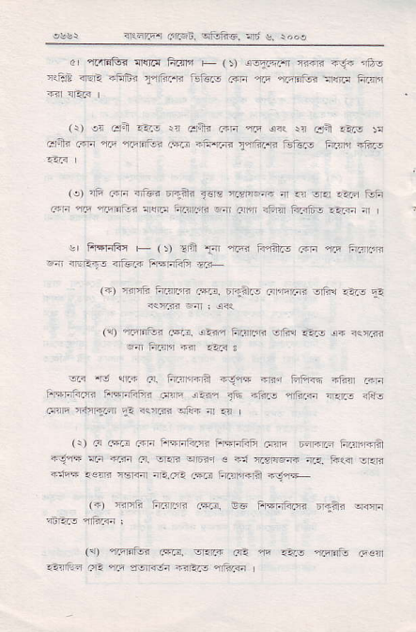
i€aF. /Jn6n !i51i5, ^{n1'} e..ol
?r rftnBt llrrtl Rrcrn + _{(t} ^{qslTnFr} r4<n ?\t-i '#s c<FE :lrEli ^{'fi6q} _{?rfii..s} rsftLc _{6'rn} ^{qrr} rontud rj!]rr A.qn
^{)r} _{6r*. 6+-} ^{q.q i.? )r} cta 5c- :r
.j:il1 ^{aEF} _{".'r} ^{ql.qitui} .5?.3 nfr.i-.I"ii?.-R tuturs Fjt15j +F.-
(e) nF airn {'tu ^{Dqa"} _{a€|!} !z3lr@ a or{l €F ftji _{F{r} ^{qai} _{"r.5Eria} 4nnr ;r.Tr5ri ^{q} c'1'1r iF"l FFrfg a?Fn m
s, FFFlitu + ^{(t} _{lrff.I4} ^{'rrH} Frfts cm ar ftan,R 6 _{{EEF} ^{qEF} FrFiFii a.+
(+) nl'A FErrF c+i3. Er.liLs ^{alrFrrs sfR {as} El
(1 4Flri- cq.!. sbn ir.nrsR srtu _{E?-3} ^{j{} nesj3 ^{q} ftErH +.r aL< s
_{v.-} -rd ^{?rF} l?- Fn?'rqa .3jF rrnd Ffi3E 4ftn arFr Ffqnfi.r. fnFtrr. Fn ^{i??d} ₁₁₊ iji69 ntujn r|.lF ijlj cfirn ^{nirFr4r} _{5- 3qr.nr} ^{q_F} rr =r I
(r) ar cFF 6{Fr FEEtoa _{F} ^{q-ffi} r:cirF FFrF ii.4.m? +9* n.a r:a a. _{srFE} ^{qFq} € ?i i.?FER nr!. F.$r -E]3 r.tcr E€G rel<4 nri..r? ^{.ric FrarrFA} <r.+
(a) aEF trirn 1?{a. _{sG FrFnftB brr.'llla} q<rrn
(n) 1Fl.tu c+.tr. wrLF _{Ga rr .as} ^{qmiG} Feir r?rina eE 3ai :tqR6n RErr 16r.
nPnrFr fa6n, _{rtu46.} ^{q6} ! i.o,
(e) FiFaffi oEF. irds _{6EM} ^{qrr€--i} !l5 E sa.l lezr s <N GI, FTEFfi GT|rr DaTfl.n 1 TT
FrFFtoa ffia Ff4 (e) s Fq
_{e} ^{_.iJ >r.eFi:@l er{l} _{"4.;1} en aPr. -nrj3 ^{FPrS.lrs} _{.A} ^{{..i.<i} ;
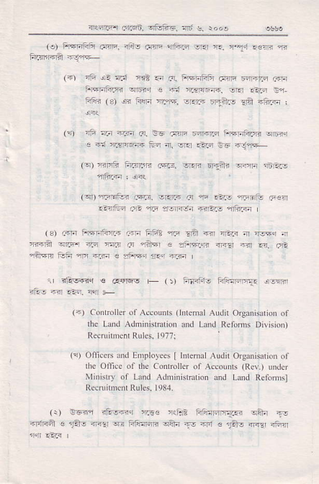
^{'i;} ?.a ati.t tA. eG .:@ D@E-r iEF]f?.a e|Fr
c *i '.q:ffi Ea a, orq a-F e€ nj.r
(q) fttrF li.rR'R f$.r. s.E Erliri rilm n6Ei.! 4ft.a ! ar{
_{lqr)} T.qfitu3 cn3. lrErJF ^{.j} nF .ZE a' Ftu .F€:n _{"5&E} ^{el} _{"F} ?1116{ Fir-lr nfiiarn
⁽³⁾ .rrn FFFfinF ...F ^{Ffi? ?M} _{!l?} nrir rEF i ni,.. { aFifi sr..., 3.d r?.r ^{ar} _{"arq} ^{e} ?il.i;-lF n!| Br rr. F. _{"r?,s ffir} ^{qtr -.r €} sf,rr rr.r ft," I
1, rlis+<6r € G{re- + (t An3.]3 tri*@q. !:5m,
⁽⁻⁾ Conlrlller ol Ac.ohrs ^{(fine} al Audir OrganharioD or rhe Land AdnrnrkhtioD and Land Refonrs Dilision) Rec ihrcn Rulcs. ls?71
(a) ^{OficeN and Ernployees} _{I} ln&Dal Audit Organisarion of $e Offce of dre Controll$ of Accounts ^{(Rcv.)} uide. Mi'ristry of Ltud Adoinisrarion and Lud Rcfonnsl Recn'nmcnl Rules. 1984.
_{(r)} ^{qcEr} ni.i5<q P.li€ adFa $Jar @y w trFlal.
r.tua _{Fl€ldl4-r.€} ^{qfti} 1- ^{qan} _{1e} ^{+ri s} _{1&r} n5r iafl
<l{nrF r,:[Fn. af-F5. ^{il6} e. rcot
B^{E}E
^{E} F l;&
E EE
F gE
- F E,E EE FE"E 5t E tt: EE€5dEB
e
E
F
E;
^{FE}6^{F} rF
E-8, FE
:E €fr
FE ;F
B ! Ets
-EFEE;s
E.E€€T fi I:
FFFF.EFI
Ex bd
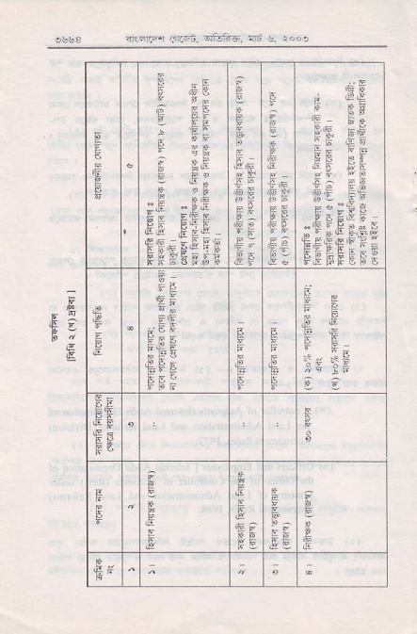
FFF6F',58
€F^{g} €F
^{E}_{F}^{E}E_{E}^{EE},E_{GA}
^{g}E
E
5E
^{*; f} "P E
E
€
E'
rE &E
_{r} ^{ra!'.4.} _{Ln-].4!rc1 fr !,} roo'
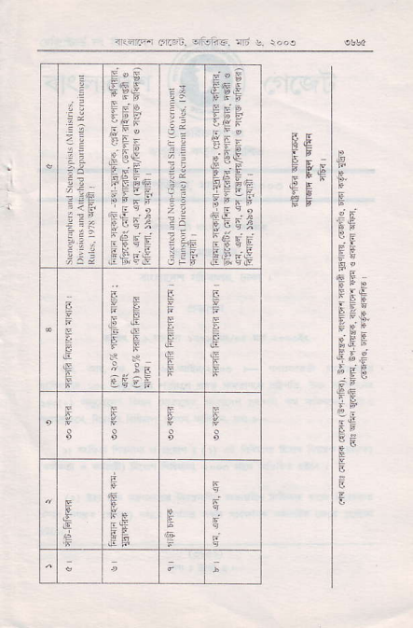
F;E
&I"
5FE
f, "-E
FR E.F ^{'F€} E,:
i3
32
d"e _{FGF}
F EE
EFF
_{E} BE
E'E Fg FF;F
EPE EE
B
\5- gE
t!.
,ESEii F
ii
g
,E't 5 ts
t9:
FIE
^{"E}E_{E}F=E
^{FF}E^{"F}E_{E}
EEF E;li" ;EE
,5EE
^{F E} F E 6
E^{q}_{F}^{F"}_{EF}E_{E}
E=

